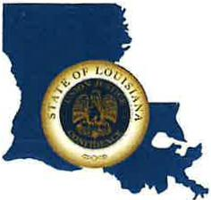 | CAPITAL AREA GROUNDWATER CONSERVATION DISTRICT
GARY I. BEARD
EXECUTIVE DIRECTOR

MEETING NOTICE
Capital Area Groundwater Conservation District
Regular Board Meeting

WHEN: Thursday, September 15, 2022

TIME: 1:30 p.m.

WHERE: Louisiana State Capitol,
House Committee Room #4,
900 N. 3rd St., Baton Rouge, Louisiana.

Contact Person: Lisa Manda, (225) 293-7370

